Report
Of
AI Web Development Internship at InAmigos Foundation
Submitted
To
School of Computer Science and Engineering
IILM University, Greater Noida, U.P.
In partial fulfilment of the requirement of degree of
B.Tech CSE

By
Roll Number of Student: 25SCS1003001645
Name of Student: ALYSSA SURI
Batch: 2025-2029

CANDIDATE'S DECLARATION
I, ALYSSA SURI, do hereby declare that the internship report titled "AI Web Development Internship at InAmigos Foundation" has been completed by me to fulfil the requirement for the award of the degree of Bachelor of Technology in CSE. All the references have been quoted and I have not taken as such any material from any other source. I affirm that this report is my own and has not been submitted to any other institute for any degree/diploma requirement, and I shall be solely responsible for any kind of copyright violation in this regard.

Signature
Student Name: ALYSSA SURI
Roll No.: 25SCS1003001645

ACKNOWLEDGEMENT
I am using this opportunity to express my gratitude to everyone who supported me throughout the Internship Program at InAmigos Foundation. I am thankful for their aspiring guidance, invaluably constructive criticism, and friendly advice during this work. I am sincerely grateful to Ms. Shahira Bhanu Shaik, Sr. HR Manager at InAmigos Foundation, for her mentorship and for sharing truthful and illuminating views on a number of issues related to this work.
I would also like to thank IILM University and the School of Computer Science and Engineering for providing me the opportunity to undertake this internship as part of my academic curriculum.
I express my gratitude to my parents for their blessings and continued support.

Signature
Student Name: ALYSSA SURI
Roll No.: 25SCS1003001645

INTERNSHIP COMPLETION CERTIFICATE
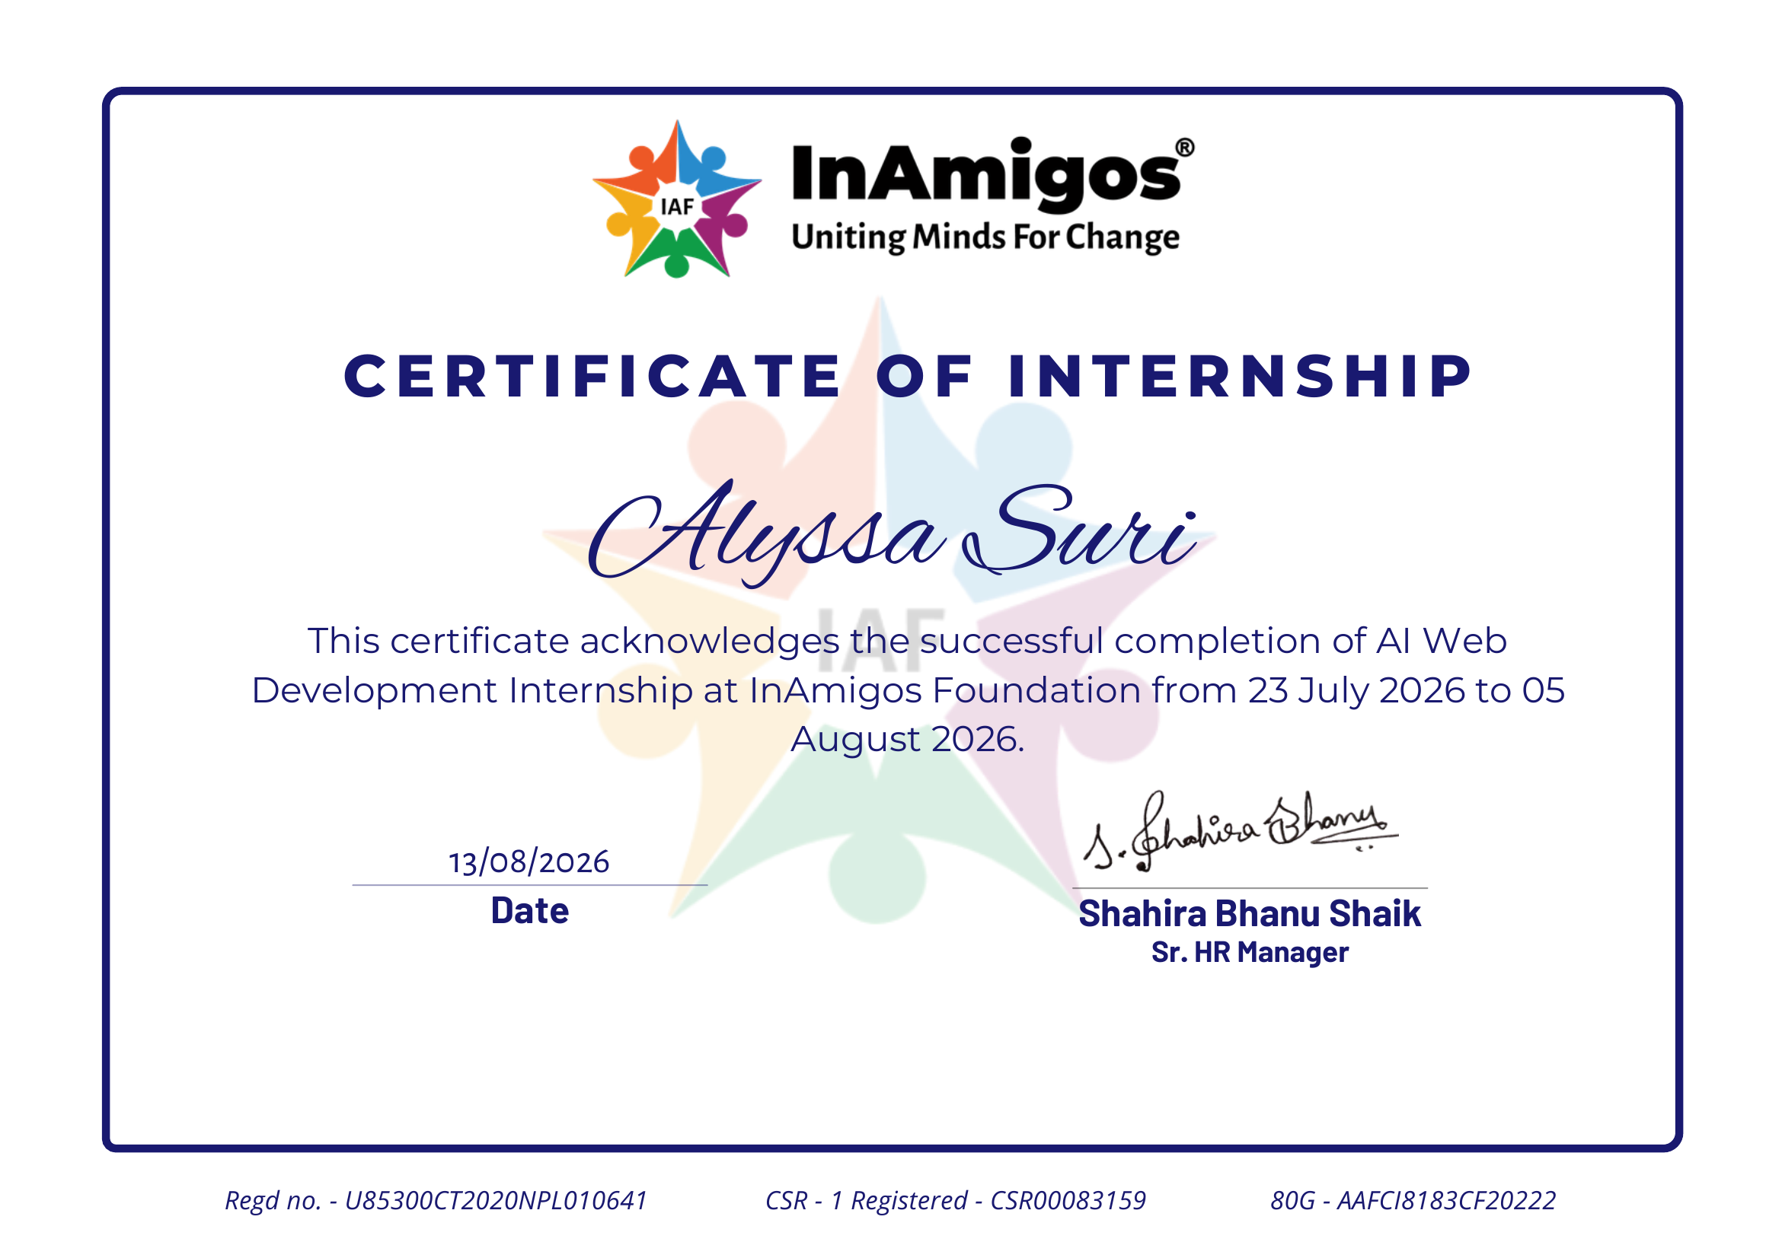
Certificate of Internship issued by InAmigos Foundation

TABLE OF CONTENTS
Chapter No. | Chapter Name | Page Nos.
 | Cover Page | i
1. | Candidate's Declaration | ii
2. | Acknowledgement | iii
3. | Internship Completion Certificate | iv
4. | Project Description | 1
 | 4.1 Introduction
 | 4.2 Organization Profile
 | 4.3 Problem Statement
 | 4.4 Project Objectives | 2
 | 4.5 Scope of the Project | 3
 | 4.6 Technologies and Tools Used
 | 4.7 System Architecture
 | 4.8 Methodology | 4
 | 4.9 Expected Outcomes | 5
 | 4.10 Certificates of Completion and Communication Proof | 5-7
5. | Bibliography/References | v

CHAPTER 4
PROJECT DESCRIPTION
4.1 Introduction
This report presents the work carried out during a two-week Artificial Intelligence (AI) Web Development internship undertaken at InAmigos Foundation, a Section-8 registered non-profit organization, from 23 July 2026 to 5 August 2026. The internship was completed remotely (work-from-home) as part of the requirement of the B.Tech CSE curriculum at IILM University.
The internship focused on applying modern web development skills alongside AI-assisted development tools to contribute to the Foundation's digital presence. The assigned work spanned building original web projects, auditing and proposing improvements to the organization's live website, prototyping redesigned interface sections, and supporting the Foundation's outreach efforts through social media and testimonials. AI tools such as Claude and Google AntiGravity were used throughout to accelerate design, coding, and content-creation tasks, reflecting the internship's core theme of combining traditional front-end development with AI-assisted workflows.
4.2 Organization Profile
InAmigos Foundation is a Section-8 registered non-profit organization licensed by the Central Government of India (Registration No. U85300CT2020NPL010641), also registered under CSR-1 (CSR00083159) and holding 80G tax-exemption status (AAFCI8183CF20222). The Foundation operates with a network of 200+ volunteers across India and works to promote arts, commerce, sports, environmental protection, and community welfare, under the guiding philosophy that "the only religion followed by our organization is humanity."
The Foundation runs structured virtual internship programs in domains such as Web Development, AI applications, Content Writing, Digital Marketing, and Graphic Design, giving students hands-on, practical exposure while contributing directly to the organization's ongoing digital and outreach initiatives.
4.3 Problem Statement
InAmigos Foundation's public website (inamigosfoundation.org.in) serves as its primary channel for donations, volunteer recruitment, and awareness of its causes and events. However, a structured audit of the live site during the internship revealed several usability and content gaps that reduce its effectiveness at converting visitors into donors and volunteers, including:
- An outdated social icon (Google+) still present in the footer despite the platform's shutdown.
- Key project names shown without explanatory context in the hero section.
- Dense, unstructured text blocks combining founding history, certifications, and project information.
- A "Causes" section with no visual preview cards for actual causes.
- An events section displaying only outdated (1+ year old) listings instead of upcoming events.
- No persistent "Donate" call-to-action in the main navigation bar.
- Visually identical Donate, Volunteer, and Join Us cards with no visual hierarchy.
Alongside this website-specific problem, interns were also tasked with independently building small AI-assisted web projects to demonstrate applied front-end and AI-tool proficiency.
4.4 Project Objectives
- To build a personal developer portfolio website showcasing skills and projects, using an AI-assisted development workflow.
- To design and build an original AI-themed web application landing page ("Learn with AI") demonstrating front-end development and AI-tool-assisted design.
- To conduct a structured UI/UX audit of the InAmigos Foundation website and document prioritized, actionable improvement recommendations.
- To prototype a redesigned "feature highlight" section (donation flow and volunteer registration) addressing key issues identified in the audit.
- To support the Foundation's outreach efforts by sharing completed project work and feedback through social media and testimonial channels.
4.5 Scope of the Project
The scope of the internship was limited to front-end web development and UI/UX analysis, and did not extend to backend, database, or server-side deployment work on the Foundation's live production website. Deliverables were confined to independently hosted demonstration projects (deployed via Vercel), a written audit and prototype of proposed improvements for the Foundation's website, and outreach/documentation tasks. Actual implementation of the audit's recommendations onto the Foundation's live website was outside the two-week scope and was handed over as a proposal document.
4.6 Technologies and Tools Used
- HTML5, CSS3, and JavaScript (ES6) for front-end structure, styling, and interactivity.
- Google AntiGravity — an AI-assisted development environment used to scaffold and build the portfolio and "Learn with AI" websites.
- Claude (Anthropic) — used for AI-assisted planning, content generation, and code assistance.
- Figma-style HTML/CSS prototyping for the website feature-highlight redesign mockup.
- Vercel — used to deploy and host both web projects for live review.
- Microsoft Word / Google Docs — used to prepare the website audit (Change Summary) and annotated screenshot documentation.
- Git & GitHub — used for version control and open-source contribution practice.
- Google Forms — used to submit structured internship experience feedback to the organization.
4.7 System Architecture
Both web projects built during the internship follow a standard static front-end architecture, structured as independent, client-side-rendered single-page layouts:
- Presentation Layer: Semantic HTML5 markup defining page sections (navigation, hero, about, services/skills, projects, contact).
- Styling Layer: CSS3 with responsive, mobile-first layout rules ensuring usability across desktop and mobile viewports.
- Behaviour Layer: JavaScript handling interactive elements such as navigation, smooth scrolling, and dynamic UI states.
- Deployment Layer: Static hosting on Vercel, providing a live public URL for each project without a dedicated backend or database.
The website audit and redesign prototype (feature-highlight mockup) followed the same static HTML/CSS structure, built independently of the Foundation's live codebase, so it could be reviewed as a visual proposal without affecting the production site.
4.8 Methodology
The internship followed a task-based methodology, with each of the four core tasks executed in sequence over the two-week period:
Task 1 — Personal Portfolio Website: Designed and built a responsive personal portfolio (About, Skills, Projects, Contact sections) using HTML, CSS, and JavaScript, generated with the assistance of Google AntiGravity and deployed live on Vercel.
Task 2 — Website Analysis: Performed a section-by-section audit of the live InAmigos Foundation website using annotated screenshots, identifying 14 distinct issues and classifying each by priority (1 Critical, 4 High, 6 Medium, 3 Low) in a structured Change Summary document.
Task 3 — AI Website ("Learn with AI"): Built an original AI-learning-platform landing page with a hero section, feature highlights, courses/services, testimonials, and contact section, again using Google AntiGravity and deployed on Vercel.
Task 4 — Feature Highlight Prototype: Translated the highest-priority findings from the Task 2 audit into a working HTML/CSS mockup demonstrating an improved "Smart Donation Section" and "Volunteer Registration" flow for the Foundation's website.
Outreach & Documentation: Shared completed project links and progress publicly on social media (tagging InAmigos Foundation) as part of the outreach component, and submitted a structured feedback form on completion of the internship.
4.9 Expected Outcomes
- Two fully functional, deployed web projects (personal portfolio and "Learn with AI") demonstrating applied HTML/CSS/JavaScript and AI-assisted development skills.
- A prioritized, actionable UI/UX improvement document for InAmigos Foundation's live website, usable by the organization's technical team.
- A working prototype demonstrating how the top-priority audit recommendations (donation flow and volunteer registration) could be implemented.
- Practical, hands-on experience with AI-assisted web development tools (Google AntiGravity, Claude) in a real-world, non-profit-facing context.
- Improved understanding of UI/UX auditing, responsive front-end development, and professional documentation practices.
- A completed Internship Completion Certificate awarded by InAmigos Foundation.
4.10 Certificates of Completion and Other Communication Mail Proof
The Internship Completion Certificate issued by InAmigos Foundation is provided below, and is also attached in Chapter 3 of this report. Screenshots of project-related social media outreach posts and the internship experience feedback form submission, serving as communication proof, are provided thereafter.

Fig 4.10.1: Certificate of Completion — AI Web Development Internship, InAmigos Foundation
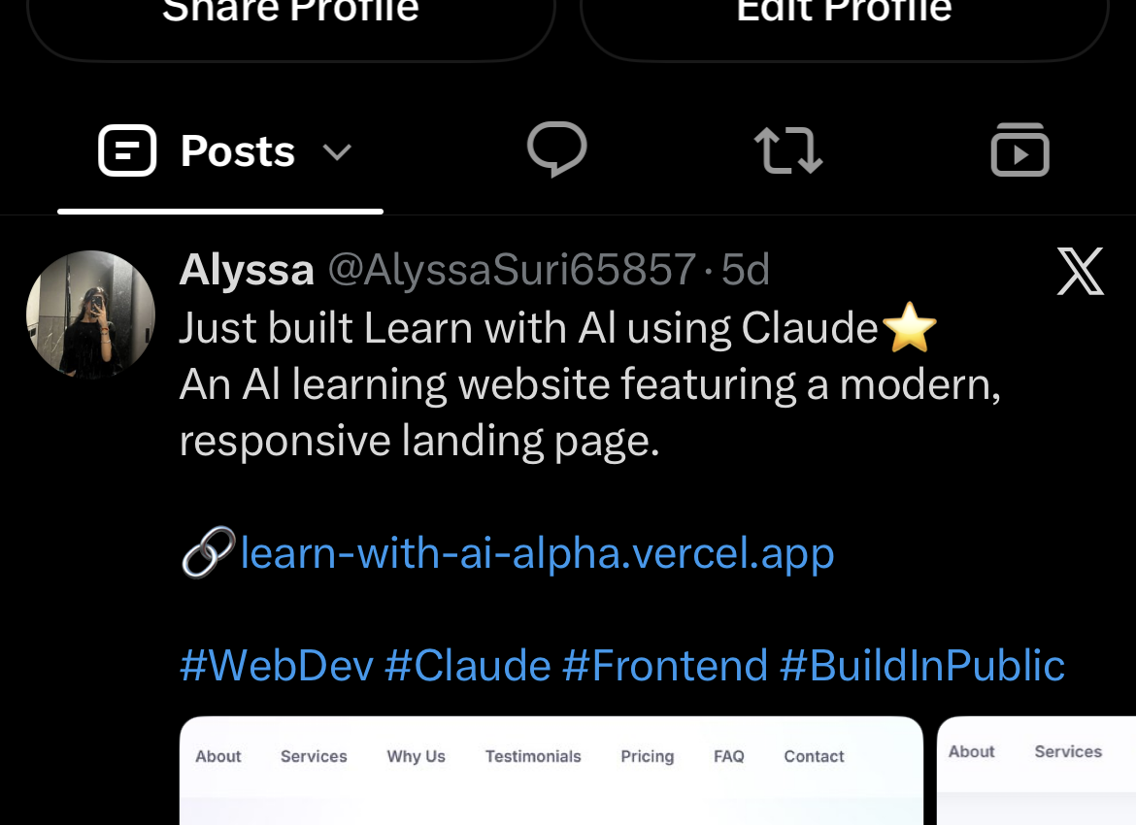
Fig 4.10.2: Social media post announcing the "Learn with AI" project
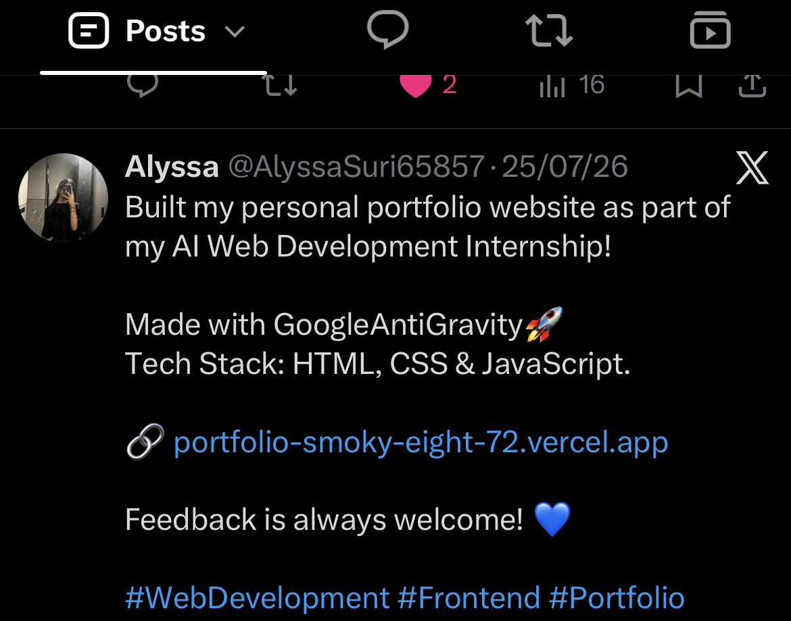
Fig 4.10.3: Social media post announcing the personal portfolio project
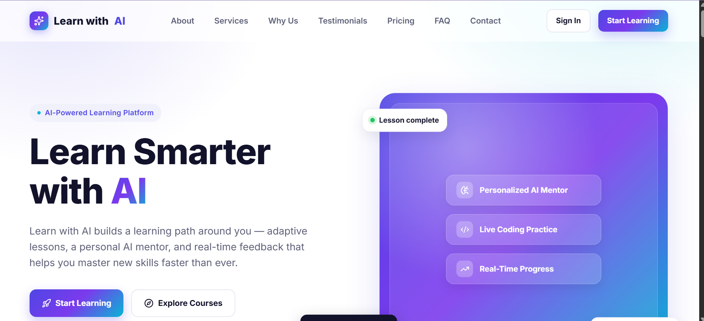
Fig 4.10.4: "Learn with AI" landing page — Task 3 deliverable
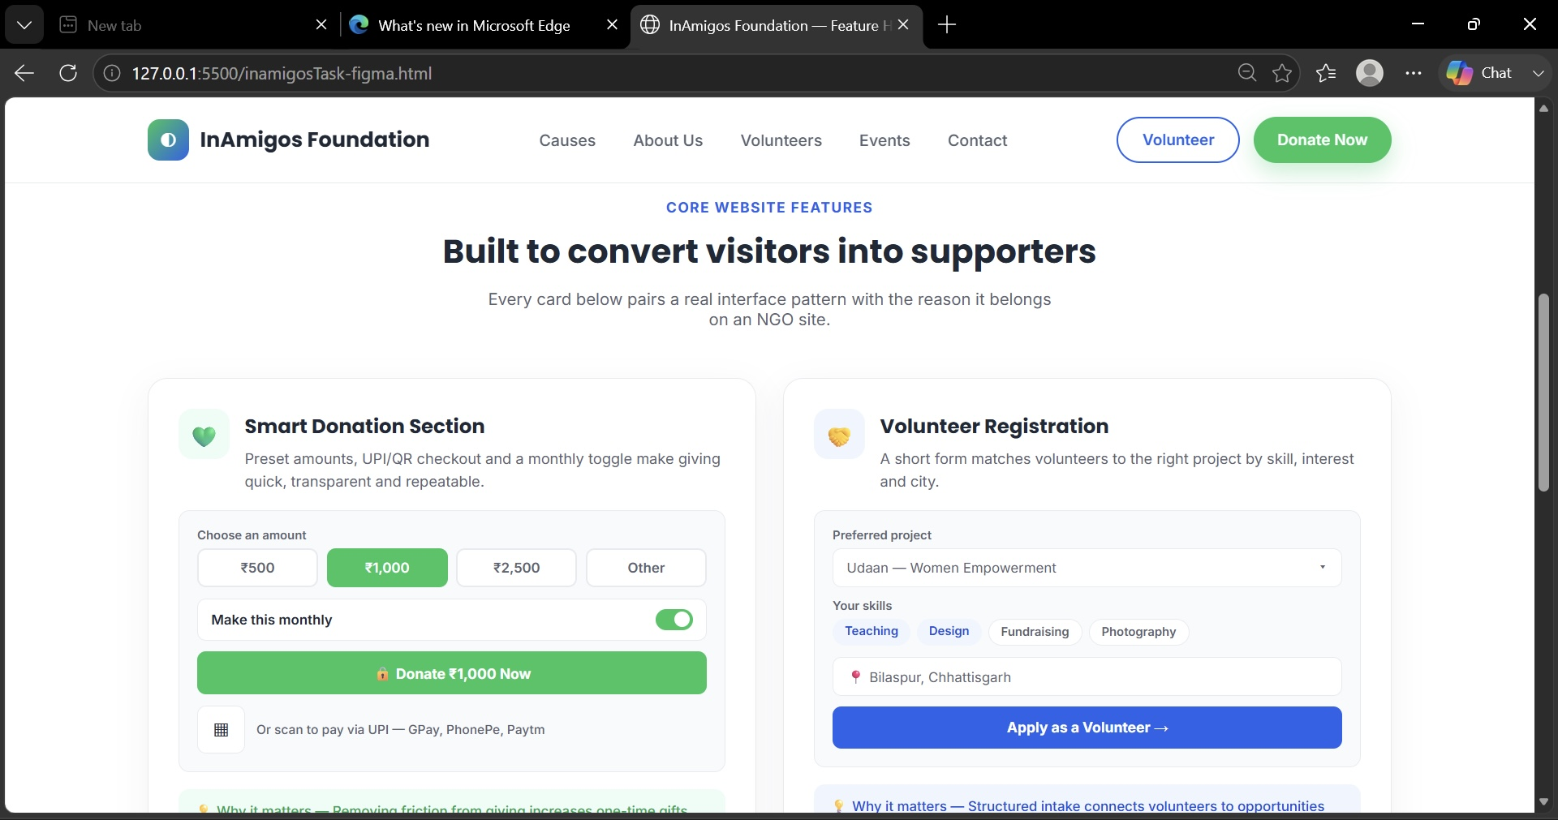
Fig 4.10.5: Feature-highlight redesign prototype — Task 4 deliverable

CHAPTER 5
BIBLIOGRAPHY / REFERENCES
[1] InAmigos Foundation, "About Us," InAmigos Foundation Official Website. [Online]. Available: https://inamigosfoundation.org.in
[2] InAmigos Foundation, "AI Web Development Internship," Internshala. [Online]. Available: https://internshala.com/company/inamigos-foundation-1597491346/
[3] freeCodeCamp, "JavaScript Algorithms and Data Structures," freeCodeCamp. [Online]. Available: https://www.freecodecamp.org/learn/javascript-algorithms-and-data-structures/
[4] SuperSimpleDev, "HTML & CSS Full Course – Beginner to Pro," SuperSimpleDev. [Online]. Available: https://courses.supersimple.dev/courses/html-css
[5] Google, "Google AntiGravity," Google Developer Tools. [Online]. Available: https://antigravity.google
[6] Anthropic, "Claude," Anthropic. [Online]. Available: https://www.anthropic.com/claude
[7] Vercel Inc., "Vercel Documentation," Vercel. [Online]. Available: https://vercel.com/docs

